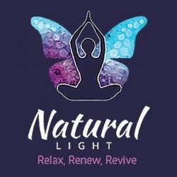

COVID-19 Pandemic Form
I, __________________________________________________, knowingly and willingly consent to have hair / skin/ body service during the COVID-19 pandemic.
I understand the COVID-19 virus has a long incubation period during which carriers of the virus may not show symptoms and still be highly contagious. It is impossible to determine who has it and who does not, given the current limits in virus testing.
I understand that due to the frequency of visits of other clients, the characteristics of the virus, and the characteristics of hair services, that I have an elevated risk of contracting the virus simply by being in the salon.
I confirm that I am not presenting any of the following symptoms of COVOID-19 listed below: • Temperature above 98.7 degrees • Shortness of breath • Loss of sense of taste or smell • Dry cough • Sore Throat
I confirm that I have not been around anyone with these symptoms in the past 14 days. _________ I do not live with anyone who is sick or quarantined.
To prevent the spread of contagious viruses and to help protect each other, I understand that I will have to follow Natural-Lights strict guidelines.
I understand that air travel significantly increases my risk of contracting and transmitting the COVID-19 virus.I agree not to attend an appointment for 4 weeks after returning from a trip.
I verify that I have not travelled outside the UK in the past 14 days to countries that have been affected by COVID-19.
.Date__________________________

Signature -------------------------------------

